AN ASSESSMENT ON GLOBAL EDUCATION DATA ANALYSIS
Individual Report By: Collins Ekpenyong Asikpo

Track no.: 23/132038

Dataset: INTERNATIONAL EDUCATION COST DATASET

Group 4
SUBMITTED TO DR. MRS. SYLVIA OLADIMEJI (HOD)

IN PARTIAL FULFILMENT OF THE REQUIREMENT TO THE DEPARTMENT OF MATHEMATICS & COMPUTER SCIENCE

FACULTY OF NATURAL AND APPLIED SCIENCE ARTHUR JARVIS UNIVERSITY, AKPABUYO, CROSS RIVER STATE.

January 2026.

1. Overview of the Project Domain
This report examines the cost of studying abroad at university level. It focuses on tuition fees, living expenses (using rent as proxy), program duration, and degree levels (Bachelor, Master, PhD) across different countries. The goal is to identify affordable and expensive destinations for international students.

2. Introduction to the Dataset
Dataset Name: International Education Costs.csv
Number of Rows: 907
Number of Columns: 12
Key Columns: Country, City, University, Program, Level, Duration_Years, Tuition_USD (annual), Rent_USD (monthly), Living_Cost_Index, Visa_Fee_USD, Insurance_USD
Main Focus: Tuition and estimated total cost for Master's programs.

3. Questions Explored
-How do tuition fees compare across Bachelor, Master, and PhD levels?
-Which countries are most/least expensive for Master's programs (including living costs)?
-What is the cost range between cheapest and most expensive Master's programs in the same country?

4. Data Cleaning Steps
I loaded CSV file using pandas and checked shape, column types, and unique values. No duplicate rows found and also no missing values in key columns.

5. Visualizations and Insights
Figure 1: Tuition Fees by Degree Level
Boxplot (log scale) comparing tuition across Bachelor, Master, and PhD.
Insight: Master's shows widest variation. USA programs dominate the high end in all levels. Many European programs have very low or zero tuition.

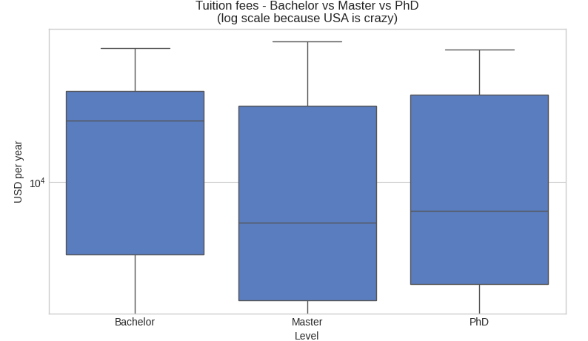

Figure 2: Top Countries by Median Total Annual Cost – Master's
Bar chart of median total cost (tuition + estimated living) for Master's programs.
Insight: USA, Singapore, Australia, UK, and Canada are most expensive. Germany, France, Nordic countries, and Austria are among the lowest.
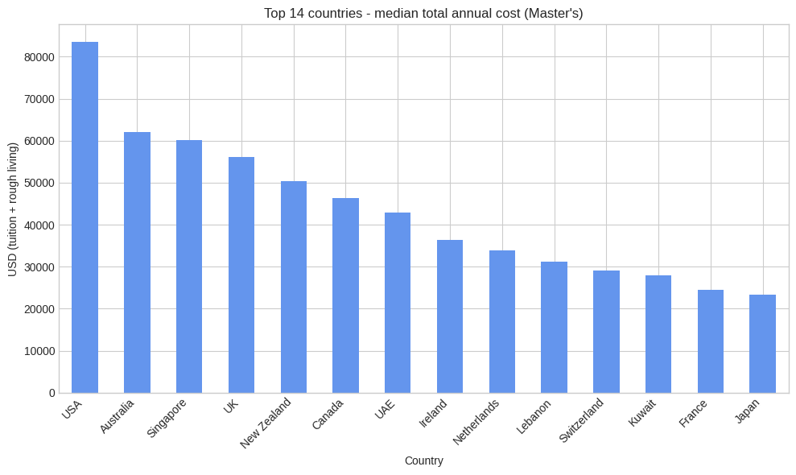

Figure 3: Cheapest vs Most Expensive Master's in Selected Countries
Bar chart showing cost range within countries (USA, UK, Canada, Australia, Germany, France, Netherlands, Japan, etc.).
Insight: Largest differences in USA, UK, Canada, Australia. Much smaller variation in Germany, France, Netherlands — living costs become main factor.
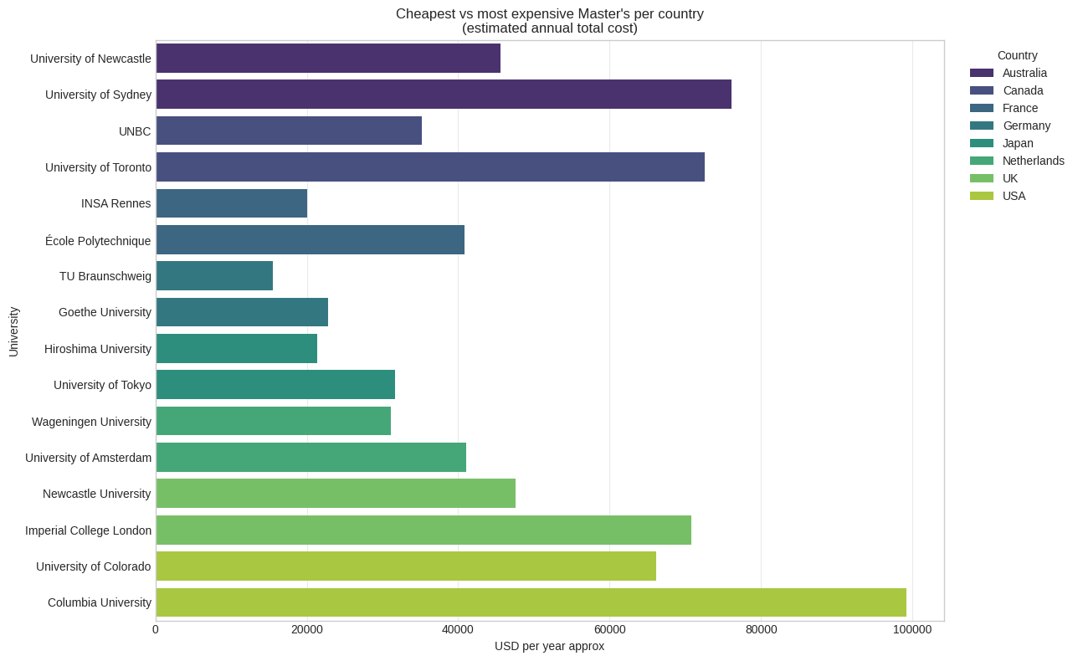

6. Conclusion
The analysis shows large global differences in higher education costs. USA, Singapore, Australia, UK, and Canada are generally very expensive (often > $40,000–60,000 per year total). Many European countries offer low or free tuition, making them more affordable even with living expenses. Within countries, cost gaps are biggest in market-driven systems (USA, UK) and smallest in publicly funded ones (Germany, France).
This provides useful information for students planning international study on a limited budget.

REFERENCES
Source Data: https://www.kaggle.com/datasets/adilshamim8/cost-of-international-education
Tools: Jupyter Notebook, pandas, matplotlib, seaborn

